**CYBER FORZA**

A reference document used to MRTG to monitoring Bandwidth [and by Nagios ]

Revision: Draft specification 1.0

July 2017

**Cyber Forza Inc. Confidential and Proprietary**

Copyright © 2017, Cyber Forza Incorporation. All rights reserved.

This document contains information that is considered proprietary and the property of Cyber Forza Inc. The content of this document may not be used in any way, duplicated, or distributed by any means without the express written permission of Cyber Forza Inc

Unless otherwise agreed in writing, by Cyber Forza Inc., The Cyber Forza products are not designed or intended for any application in which the failure of the product could create a situation where personal injury or death may occur.

Cyber Forza Inc. may change specifications and product description at any time, without notice.

Contact Cyber Forza Inc. to obtain latest specification.

# Contents

1 1 Revision History……………………………………………………………….….….4

2 Quick Start Guide ……………………………………………………………….….… 5

2.1 System Specification….…………………………………………………………..… 5

2.2 Support Information...…………………………………....……………………….…5

2.3 Getting Started………………………………….………….………………….…… 5

2.4 Install SNMP …………………………………………………………………….….5

3 Install MRTG3 …………………………………………..……………………….….6

3.1 Create a configuration file for MRTG……………………………………….……...7

3.3 Configuring Apache for MRTG………….………………………………….….…...9

3.4 Create and index file for the webserver…………………………………………...…9

4 Configuring MRTG accessible by Nagios…………………………………………...11

4.1 Add Menu Extra Tools for MRTG stats…………………………………………….12

5 Monitoring Bandwidth / Traffic Rate.........................................................................14

# 1 Revision History

|  |  |  |
| --- | --- | --- |
| Date | Revision No. | Description |
| 12/07/17 | Draft Release 1.0 | Initial version |
|  |  |  |

# 2 Quick Start Guide

# 2.1 System Specification

*Table 1: System Configuration*

|  |
| --- |
| * Ubuntu 16.04.1 LTS (Linux Kernel 4.4) |
| * System RAM: 3911776 KB |
| * Hard Disk space: 21.1 GB |
| * OS type: 64-bit |
| * Memory: 3.7 GiB |
| * Processor: Intel Core 2 Duo CPU E8400 @ 3.00GHz x 2 |

# 2.2 Support Information

* Please contact the Cyber Forza Inc. team for support

# 2.3 Getting Started

The Multi Router Traffic Grapher (MRTG) is a tool to monitor the traffic load on network links. MRTG generates HTML pages containing PNG images which provide a LIVE visual representation of this traffic.  
MRTG Uses a highly portable SNMP implementation

# 2.4 Install SNMP

*sudo vi /etc/snmp/snmpd.conf*

*sudo apt-get install snmpd snmp*

Uncomment the following line

*#rocommunity public localhost*

Save and exit the file

You need to restart the snmpd service

using the following command

sudo service  *snmpd start.*

# 3 Install MRTG

Install MRTG using the following command

*sudo apt-get install mrtg*  
  
MRTG Configuration  
  
You need to create mrtg directory under /var/www/html  
  
*sudo mkdir /var/www/html/mrtg*

# 3.1 Create a configuration file for MRTG

*cfgmaker @ > /etc/mrtg.cfg*  
In this case we are using local server we are trying to monitor and output looks similar to the  
 *cfgmaker public@localhost > /etc/mrtg.cfg*  
*-base: Get Device Info on public@localhost:  
--base: Vendor Id: Unknown Vendor - 1.3.6.1.4.1.8072.3.2.10  
--base: Populating confcache  
--base: Get Interface Info  
--base: Walking ifIndex  
--snpd: public@localhost: -> 1 -> ifIndex = 1  
--snpd: public@localhost: -> 2 -> ifIndex = 2  
--snpd: public@localhost: -> 3 -> ifIndex = 3  
--base: Walking ifType  
--snpd: public@localhost: -> 1 -> ifType = 24  
--snpd: public@localhost: -> 2 -> ifType = 6  
--snpd: public@localhost: -> 3 -> ifType = 6  
--base: Walking ifAdminStatus  
--snpd: public@localhost: -> 1 -> ifAdminStatus = 1  
--snpd: public@localhost: -> 2 -> ifAdminStatus = 1  
--snpd: public@localhost: -> 3 -> ifAdminStatus = 1  
--base: Walking ifOperStatus  
--snpd: public@localhost: -> 1 -> ifOperStatus = 1  
--snpd: public@localhost: -> 2 -> ifOperStatus = 1  
--snpd: public@localhost: -> 3 -> ifOperStatus = 1  
--base: Walking ifMtu  
--snpd: public@localhost: -> 1 -> ifMtu = 65536  
--snpd: public@localhost: -> 2 -> ifMtu = 1500  
--snpd: public@localhost: -> 3 -> ifMtu = 1500  
--base: Walking ifSpeed  
--snpd: public@localhost: -> 1 -> ifSpeed = 10000000  
--snpd: public@localhost: -> 2 -> ifSpeed = 1000000000  
--snpd: public@localhost: -> 3 -> ifSpeed = 1000000000*  
If you see the following error after running the above command you need to make sure you have completed the SNMP change discussed in the starting of this guide  
**ERROR: did not find any matching data in cfg file**Backup the original /etc/mrt.cfg file:  
  
Now you need to edit the */etc/mrt.cfg* file  
  
     *vi sudo /etc/mrt.cfg*  
  
change the working directory from  
  
*WorkDir: /var/www/mrtg*  
    to  
  
*WorkDir:  /var/www/html/mrtg*  
  
Save and exit the file  
For example to monitoring multiple devices:  
for server1, server2 and router1:  
*cfgmaker --global 'WorkDir: /var/www/mrtg' --output /tmp/server1.cfg*[*public@server1.example.comcfgmaker*](mailto:public@server1.example.comcfgmaker)*--global 'WorkDir: /var/www/mrtg' --output /tmp/server2.cfg*[*public@server2.example.comcfgmaker*](mailto:public@server2.example.comcfgmaker)*--global 'WorkDir: /var/www/mrtg' --output /tmp/router1.cfg*[*public@router1.example.com*](mailto:public@router1.example.com)  
Next, update main config file by updating all /tmp/*.cfg config file:  
Code:  
cat /tmp/server{1,2}.cfg /tmp/router1.cfg >> /etc/mrtg.cfg  
Just create graphs for all devices:        Code:  
env LANG=C /usr/bin/mrtg /etc/mrtg.cfg /usr/bin/mrtg  /etc/mrtg.cfg"

# 3.3 Configuring Apache for MRTG

In */etc/apache2/apache2.conf* add  
  
*Alias /mrtg "/var/www/html/mrtg/"  
  
<Directory "/var/www/html/mrtg/">  
        Options None  
        AllowOverride None  
        Require all granted  
</Directory>*

# 3.4 Create and index file for the webserver

    indexmaker /etc/mrtg.cfg > /var/www/html/mrtg/index.html

You can access  now MRTG using the following URL  
  
    <http://server/mrtg>

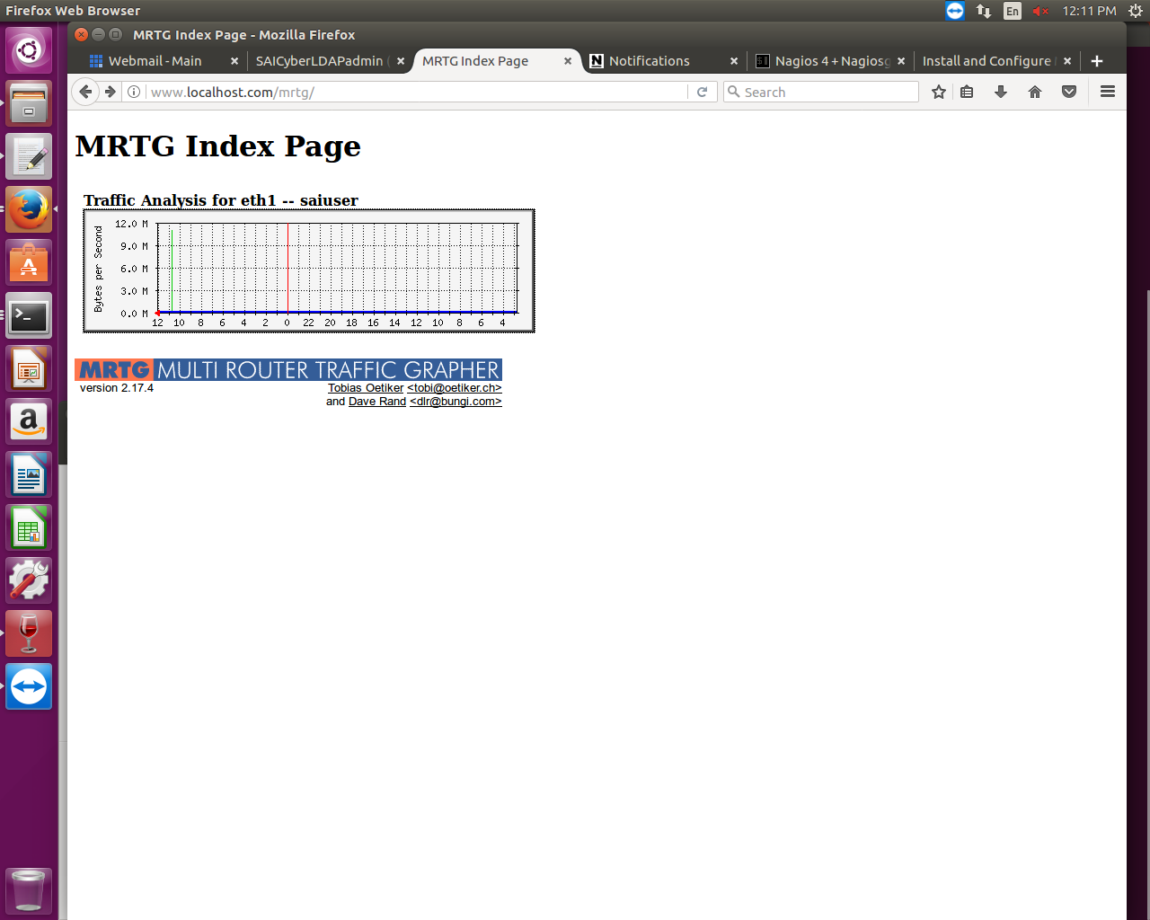

Figure1: http://localhost/mrtg

Add this task to the crontab:

*/etc/cron.d/mrtg  
*/5 *   * * *   root    if [ -x /usr/bin/mrtg ] && [ -r /etc/mrtg.cfg ] && [ -d "$(grep '^[[:space:]]*[^#]*[[:space:]]*WorkDir' /etc/mrtg.cfg | awk '{ print $NF }')" ]; then mkdir -p /var/log/mrtg ; env LANG=C /usr/bin/mrtg /etc/mrtg.cfg 2>&1 | tee -a /var/log/mrtg/mrtg.log ; fi*

# **4 Configuring MRTG accessible by Nagios**

MRTG: We are going to use MRTG to create some information about how Nagios is  
running. It shows you stats about how many check run and how long they take.  
This gives you insight in your monitoring system.  
  
Copy the included configuration from Nagios:

*cp /tmp/nagios-4.1.1/sample-config/mrtg.cfg  
/usr/local/nagios/etc/*

Create a folder for the graphs and files:  
  
 *mkdir -p /usr/local/nagios/share/stats*  
Configure MRTG to use this folder:

*vim  /usr/local/nagios/etc/mrtg.cfg*  
  
Add the following at the top of the file:  
  
 *WorkDir: /usr/local/nagios/share/stats*

Do the initial run:

*env LANG=C /usr/bin/mrtg /usr/local/nagios/etc/mrtg.cfg*

Create the HTML pages:  
 */usr/bin/indexmaker /usr/local/nagios/etc/mrtg.cfg output=/usr/local/nagios/share/stats/index.html*Finally create a cron job to run MRTG every 5 minutes:

*vim /etc/cron.d/mrtg-nagios*

Add the following:  
  
 */5 * * * *  root  env LANG=C /usr/bin/mrtg /usr/local/nagios/etc/mrtg.cfg

You can now navigate to <https://serverip/nagios/stats/> to see the graphs.

# **4.1 Add Menu Extra Tools for MRTG stats**

Last but not least we'll add a link to the Nagios menu to these new  
tools.  
  
Edit the sidebar file:

*vim /usr/local/nagios/share/side.php*  
And add the following somewhere in the menu:  
  
*<div class="navsection">  
    <div class="navsectiontitle">****Extra Tools****</div>  
        <div class="navsectionlinks">  
            <ul class="navsectionlinks">  
                <li><a href="/nagios/stats" target="<?php echo  
$link_target;?>">****MRTG stats****</a></li>  
            </ul>  
        </div>  
    </div>  
</div>*

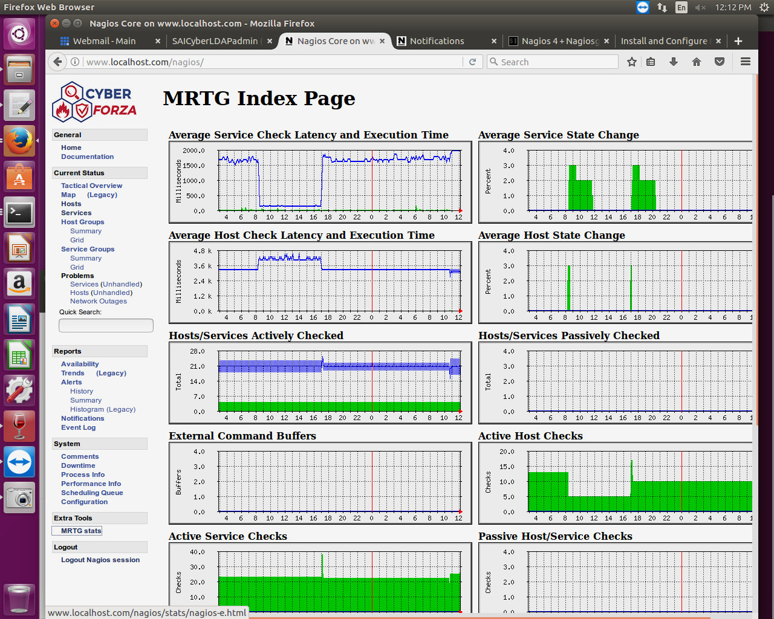

Figure2: MRTG stats

# 5 Monitoring Bandwidth / Traffic Rate

You can have Nagios alert you when traffic rates exceed thresholds you specify If you're monitoring bandwidth usage on your switches or routers using MRTG,. The *check_mrtgtraf* plugin is included in the Nagios plugins distribution, and allows you to do this.

You will need to let the *check_mrtgtraf* plugin know what log file the MRTG data is being stored in, along with thresholds. In this example we are monitoring one of the ports on a Linksys switch. The MRTG log file is stored in */var/lib/mrtg/192.168.x.x.log*. Here's the service definition we could use to monitor the bandwidth data that's stored in the log file.

*define service {*

*use generic-service ; Inherit values from a template*

*host_name linksys*

*service_description Bandwidth Usage*

*check_command check_local_mrtgtraf!/var/lib/mrtg/192.168.x_x.log!AVG!1000000,2000000!5000000,5000000!10*

*}*

In the example above, the "/var/lib/mrtg/192.168.1.253_1.log" option that gets passed to the *check_local_mrtgtraf* command tells the plugin which MRTG log file to read from. The "AVG" option tells it that it should use average bandwidth statistics. The "1000000,2000000" options are the warning thresholds (in bytes) for incoming and outgoing traffic rates respectively. The "5000000,5000000" are critical thresholds (in bytes) for incoming and outgoing traffic rates respectively. The "10" option causes the plugin to return a CRITICAL state if the MRTG log file is older than 10 minutes (it should be updated every 5 minutes).

Save the file.

Restarting Nagios Core

Once you've added the new host and service definitions to the switch.cfg file, you're ready to start monitoring the router/switch.

Links reference:  
http://www.ubuntugeek.com/install-and-configure-mrtg-on-ubuntu-16-04-server.html

https://assets.nagios.com/downloads/nagioscore/docs/nagioscore/4/en/monitoring-routers.html

https://www.iceflatline.com/2009/08/how-to-install-and-configure-mrtg-on-ubuntu-server https://www.experts-exchange.com/questions/26442785/Configuring-MGRT-for-multiple-devices.html